Jenkins Assignment 11 using pipeline
Build and deploy project on slave-1 using pipeline , so project is present on GitHub
Step 1 – lauch 1st master instance and do all set up like tomcat, java, Jenkins and open Jenkins dashboard
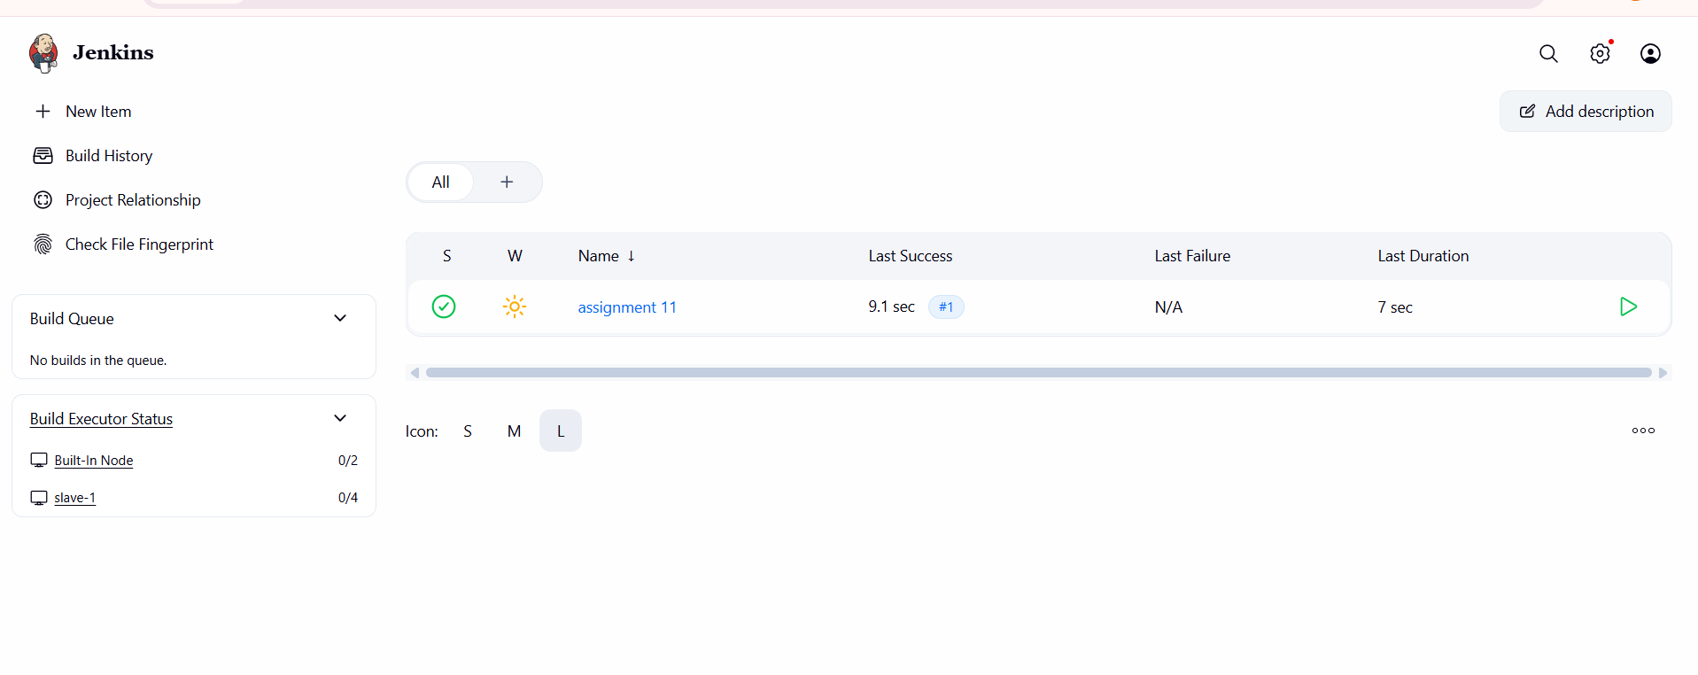
Step 2 – create 1 nodes and also lauch another instance then wget tomcat and install maven set env.
And create nodes and do set up
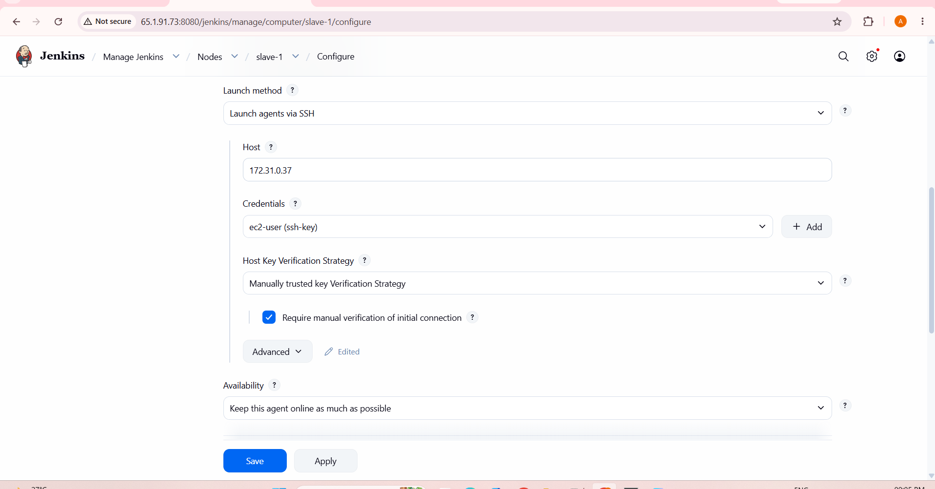
Step 3 – create 1 pipeline and add code
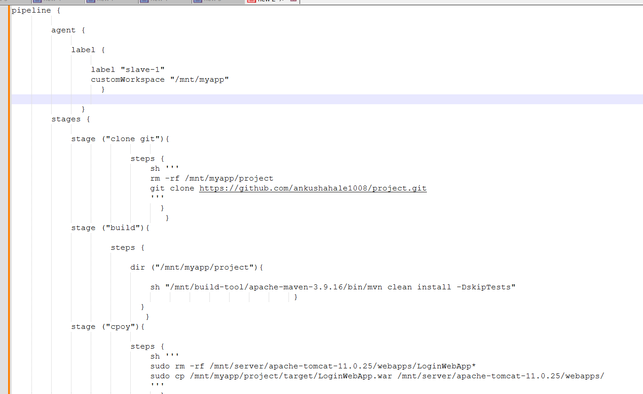
Step 4 – click on apply then build now and check using url like http://ip:8080/LoginWebApp
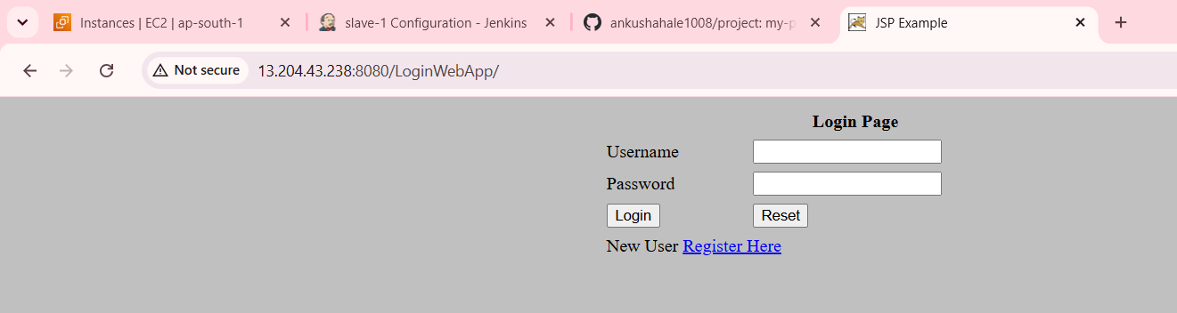
Done Successfully

